'Lab: Azure Functions – data transfer between blogs'

---

Table of Contents

Introduction: 2

# Lab: Implement task processing logic by using Azure Functions | Student lab manual 2

## Lab scenario 2

## Objectives 2

Objective: 2

Instructions 3

Exercise 1: Create Azure resources 3

Task 1: Open the Azure portal 3

Task 2: Create an Azure Storage account 3

Task 3: Create a function app 6

> **Review**: In this exercise, you created all the resources that you'll use for this lab. 8

Exercise 2: Configure local Azure Functions project 8

Task 1: Create new function 8

integrate your blobs into the created function 10

Provide Trigger and output function 10

Configure code and test 10

Review : In this section you created and configured function to copy the blob from one container to another container 11

Exercise 3: Test the Function performance 11

Upload any blob[file] in container data [observer the logsection] 11

Check the target container ‘Backup’ 12

Review: the blob uploaded in container [data] is copied to container [backup] 12

Exercise 7: Clean up your subscription 12

Task 1: Open Azure Cloud Shell and list resource groups 12

#### Task 2: Delete a resource group 12

> **Review**: In this exercise, you cleaned up your subscription by removing the resource group that was used in this lab. 12

# Introduction:

What is logic app: <https://docs.microsoft.com/en-us/azure/logic-apps/logic-apps-overview>

What is Function: <https://www.youtube.com/watch?v=vweBEaxRBfo&feature=youtu.be>

# # Lab: Implement task processing logic by using Azure Functions | Student lab manual

## ## Lab scenario

Your company has built a desktop software tool that c a local configuration file which store the information about the server configuration settings. During its latest meeting, your team decided to reduce the number of files that are distributed with your application by serving your default configuration settings from a URL instead of from a local file. As the new developer on the team, you've been tasked with evaluating Microsoft Azure Functions as a solution to this problem.

## ## Objectives

After you complete this lab, you'll be able to:

* Create an Azure Functions app in the Azure Portal.
* Create a local Azure Functions project using the [Azure Functions Core Tools][azure-functions-core-tools].
* Create various functions by using built-in triggers and input integrations.

Deploy a local Azure Functions project to Azure.

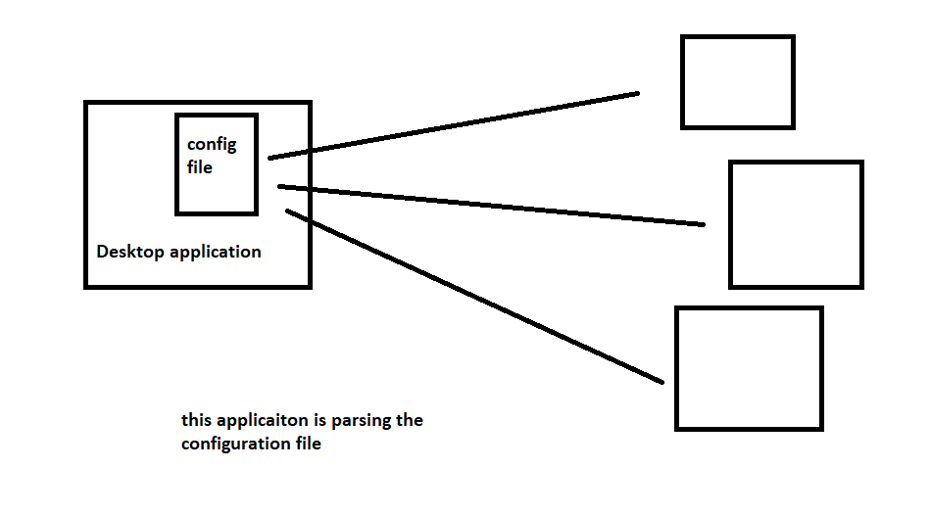

## Objective:

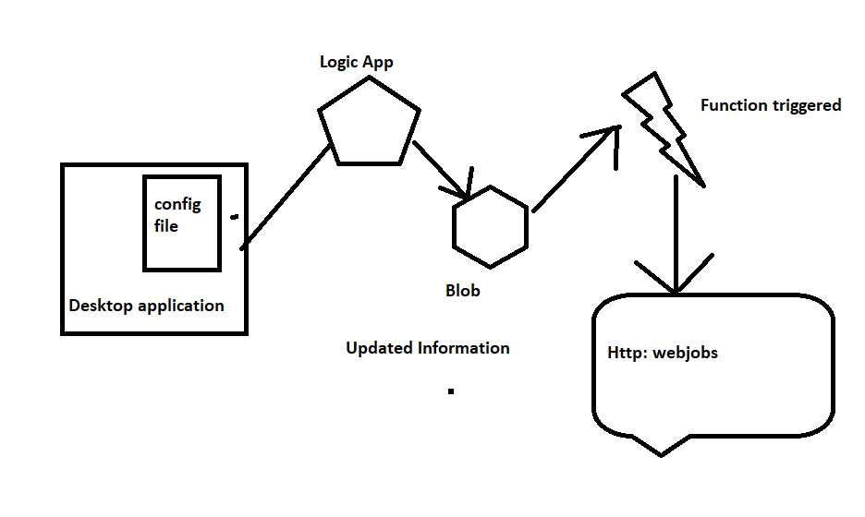

## Instructions

### Before you start

#### Review the installed applications

* Windows 10
* Microsoft Edge
* File Explorer
* Windows Terminal
* Visual Studio Code
* Azure Functions Core Tools

# Exercise 1: Create Azure resources

## Task 1: Open the Azure portal

* Sign into the Azure portal (<https://portal.azure.com>).
* If this is your first time signing in to the Azure portal, a dialog box offering a tour of the portal will appear. If you prefer to skip the tour, select **Get Started**.

## Task 2: Create an Azure Storage account

Create a new storage account with the following details:

* New resource group: **Serverless**
* Name: **Name of choice**
* Location: **(US) East US**
* Performance: **Standard**
* Account kind: **StorageV2 (general purpose v2)**
* Replication: **Locally-redundant storage (LRS)**
* Access tier: **Hot**

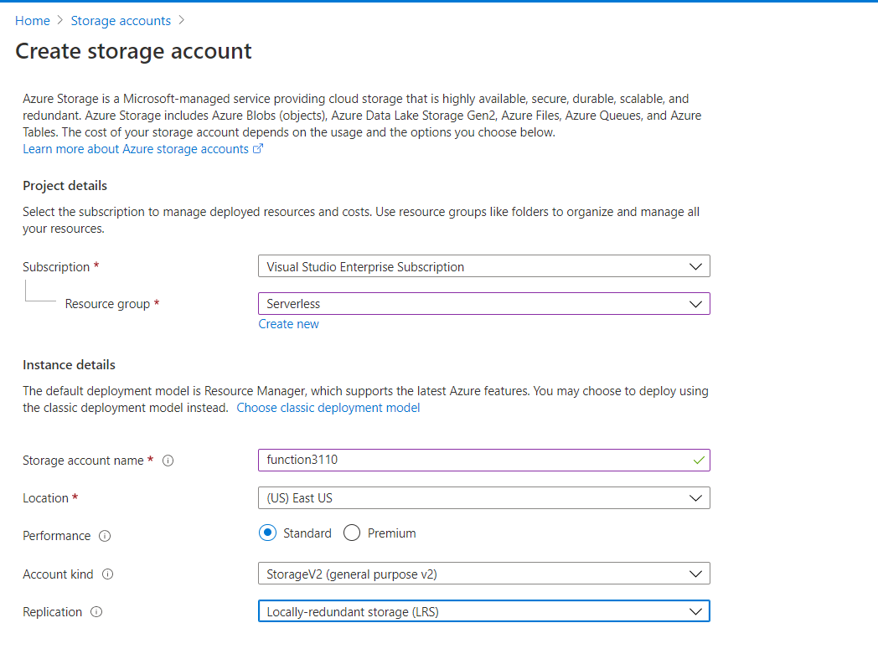

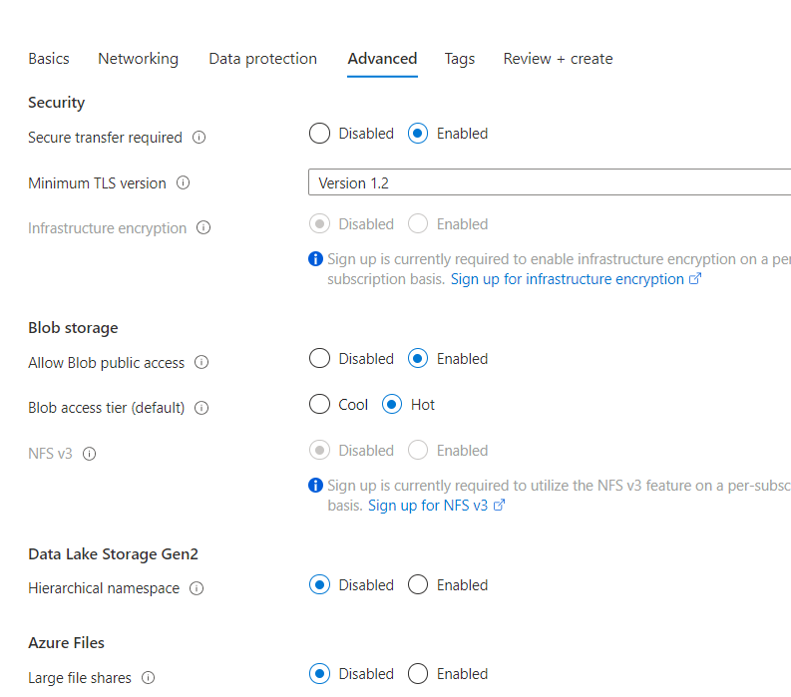

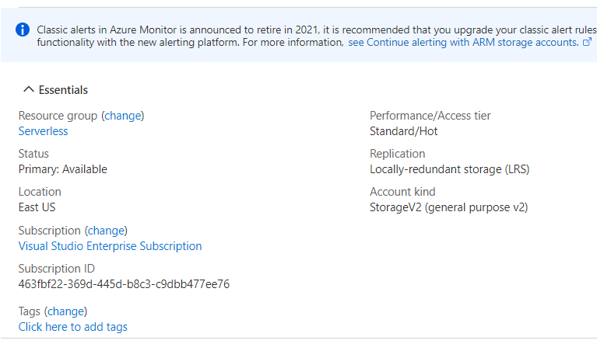

> **Note**: Wait for Azure to finish creating the storage account before you move forward with the lab. You'll receive a notification when the account is created.

Create source and target blob in the Storage Account

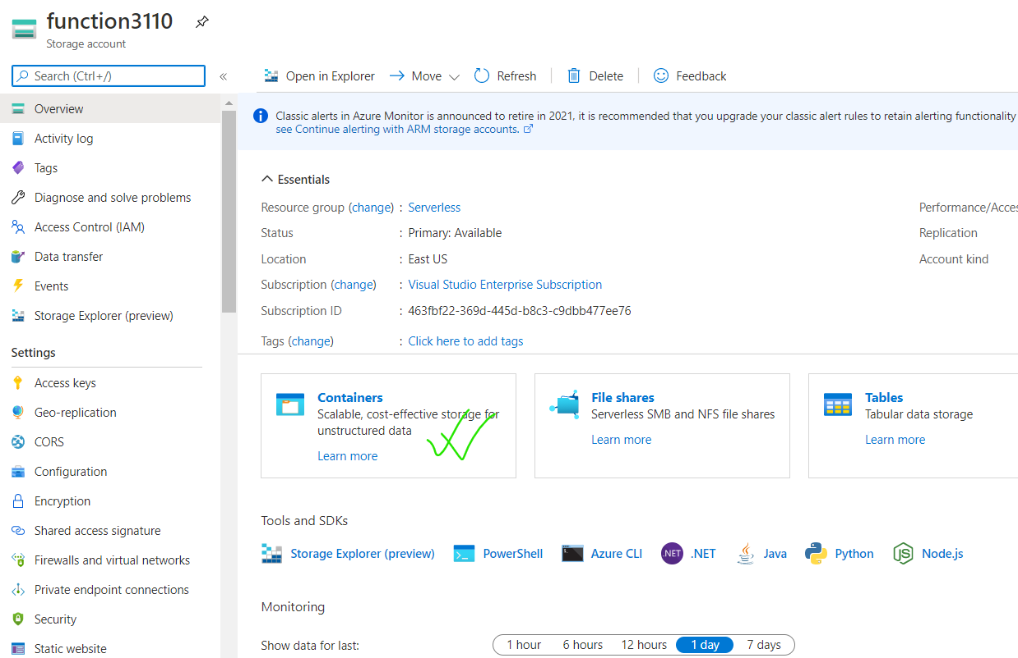

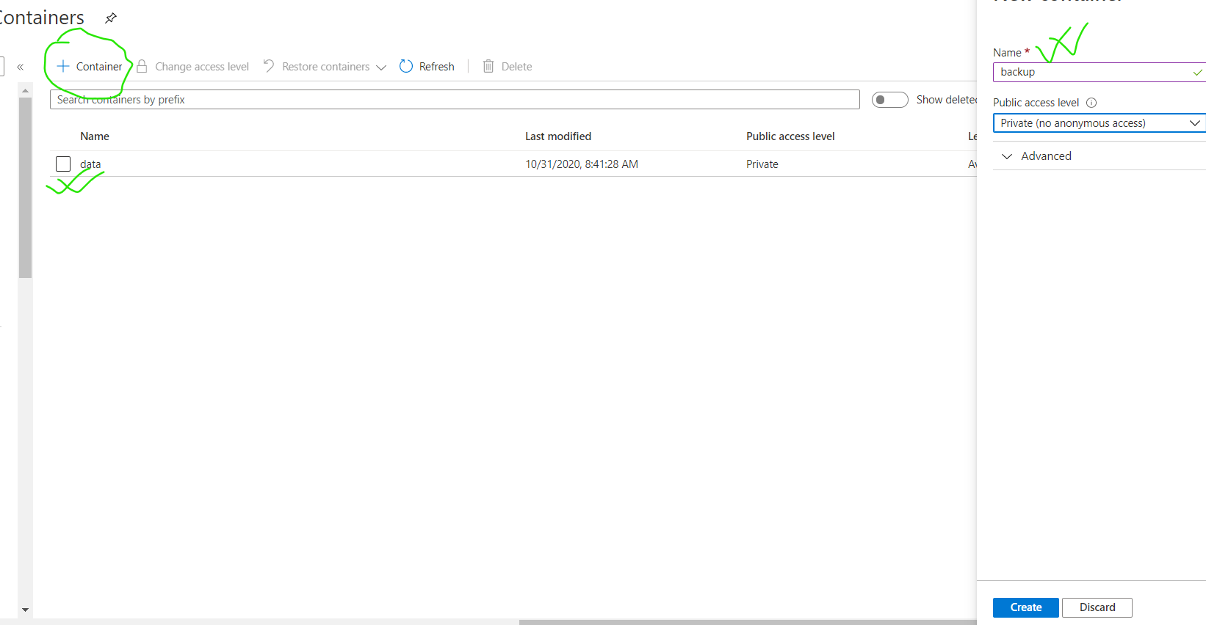

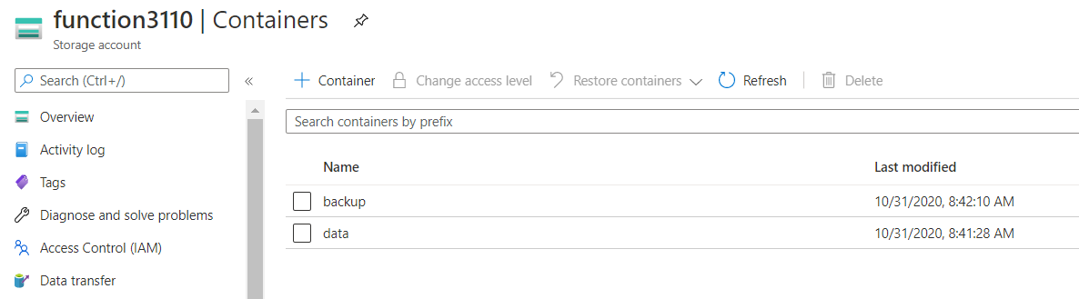

> **Note**: these blobs would work as source and target containers. Data uploaded in container ‘data’ should be copied in container ‘backup’

## Task 3: Create a function app

1. Create a new function app with the following details:

* Existing resource group: **Serverless**
* App name: **funclogic[yourname]**
* Publish: **Code**
* Runtime stack: **.NET Core**
* Version: **3.1**
* Region: **East US**
* Operating system: **Linux**
* Storage account: **funcstor[yourname]**
* Plan: **Consumption**
* Enable Application Insights: **Yes*
* 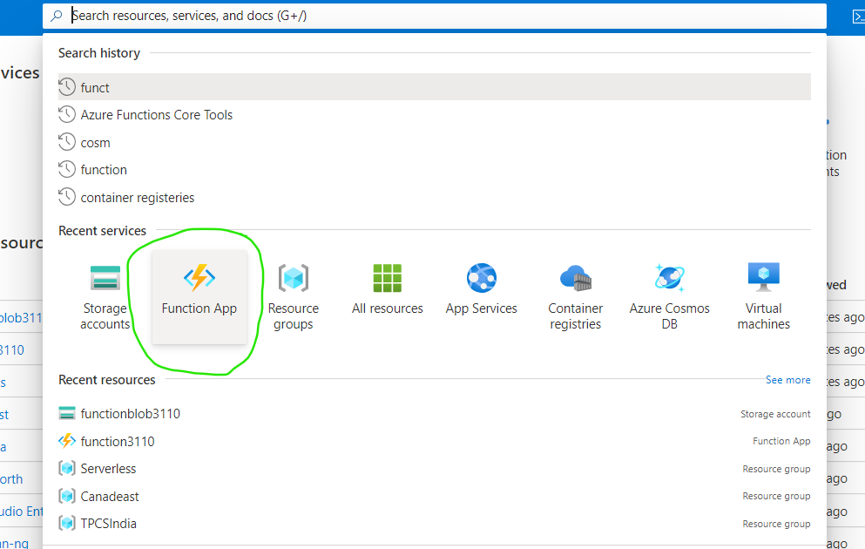
* 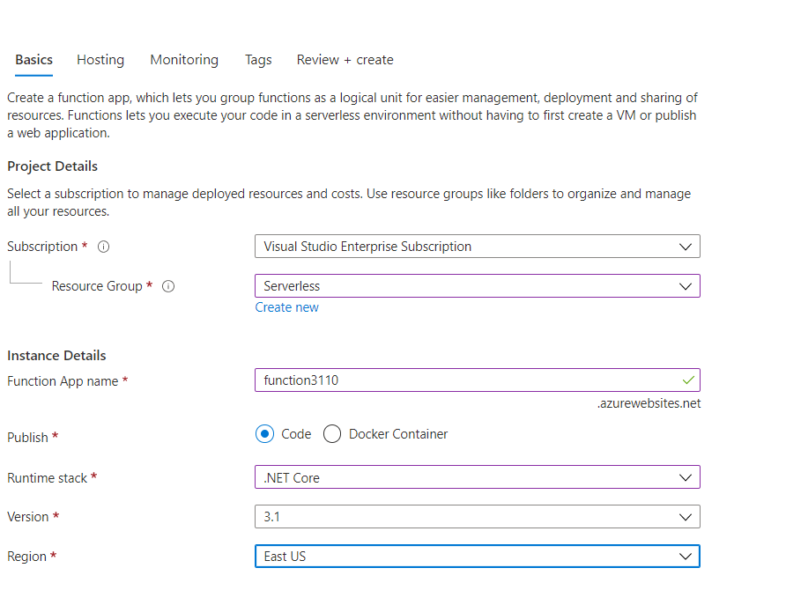

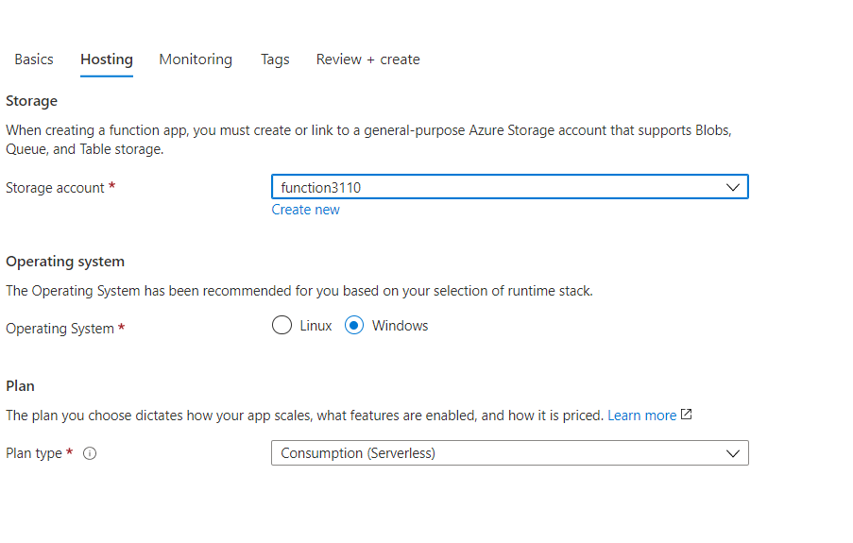

Check if the function is created

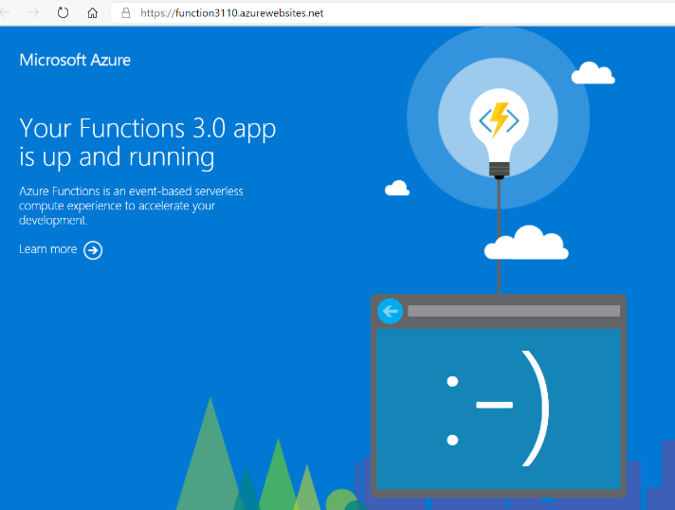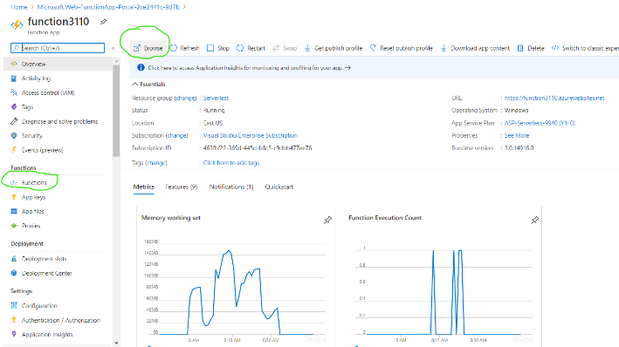

> **Note**: Wait for Azure to finish creating the function app before you move forward with the lab. You'll receive a notification when the app is created.

# > **Review**: In this exercise, you created all the resources that you'll use for this lab.

# Exercise 2: Configure local Azure Functions project

## Task 1: Create new function

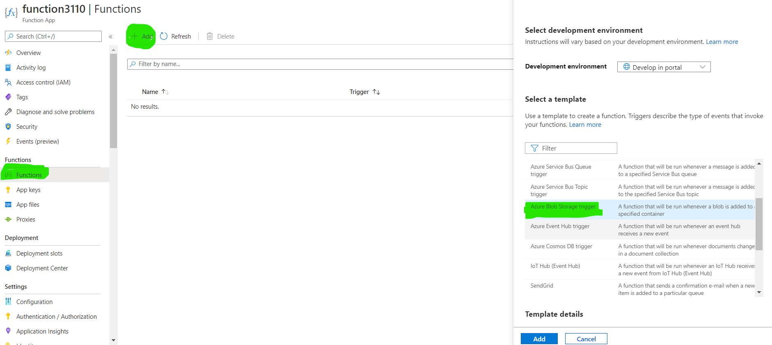

Provide name of the source container in the path section

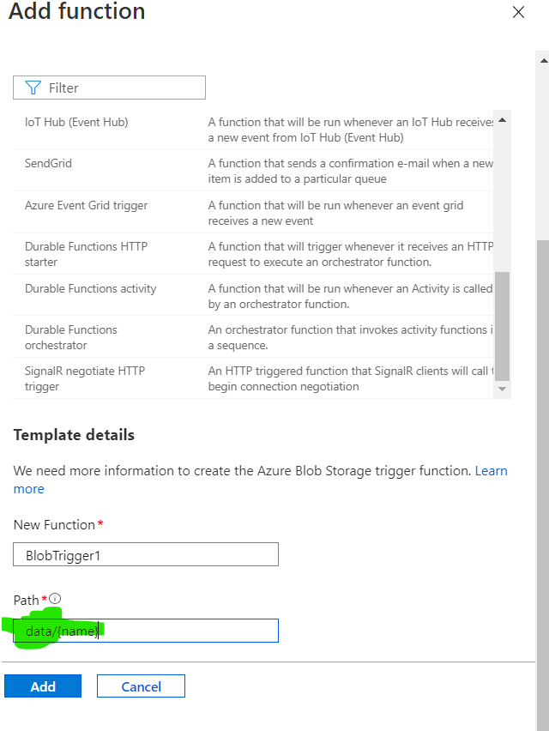.

### integrate your blobs into the created function

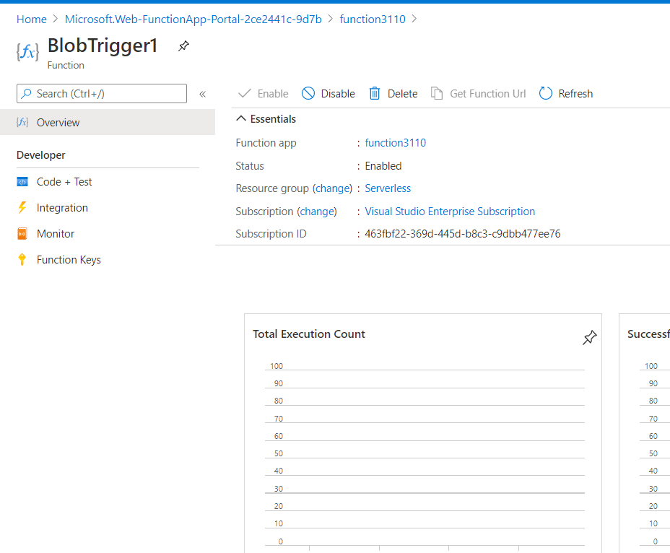

### Provide Trigger and output function

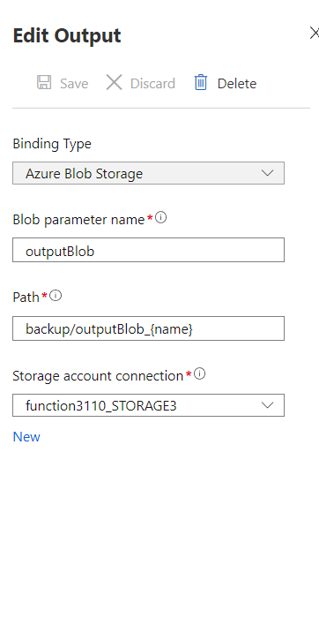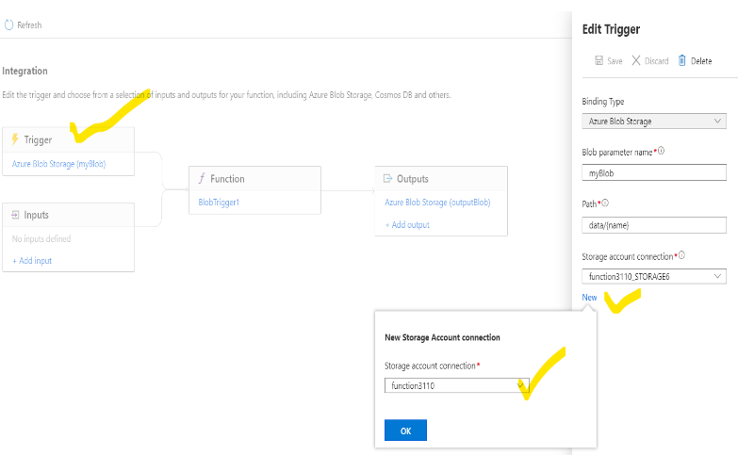

### Configure code and test

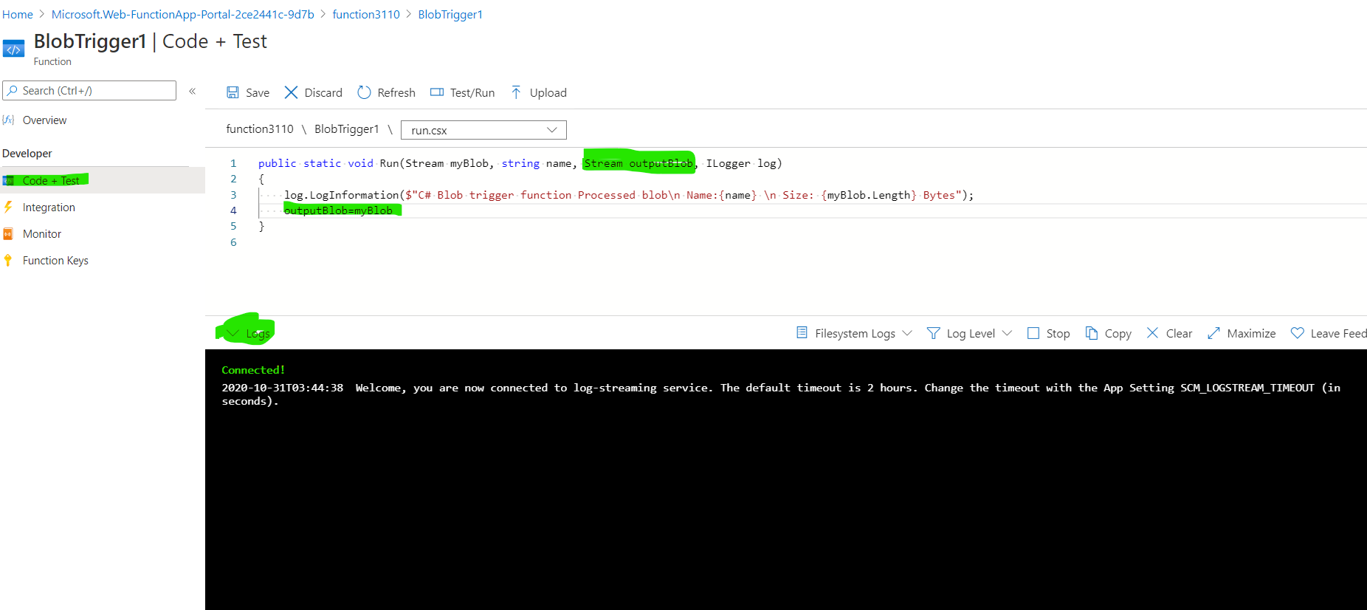 ```

# Review : In this section you created and configured function to copy the blob from one container to another container

## Exercise 3: Test the Function performance

## Upload any blob[file] in container data [observer the logsection]

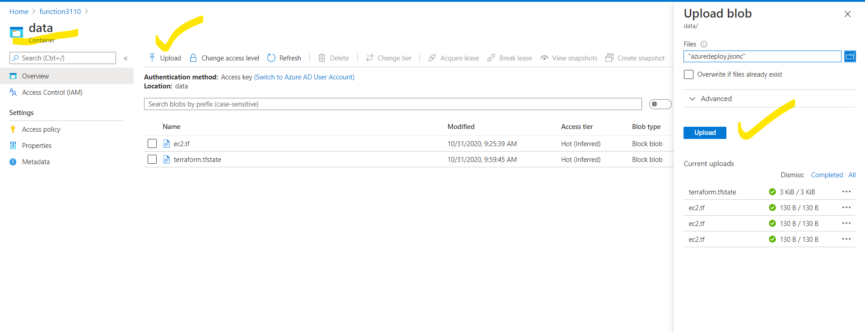

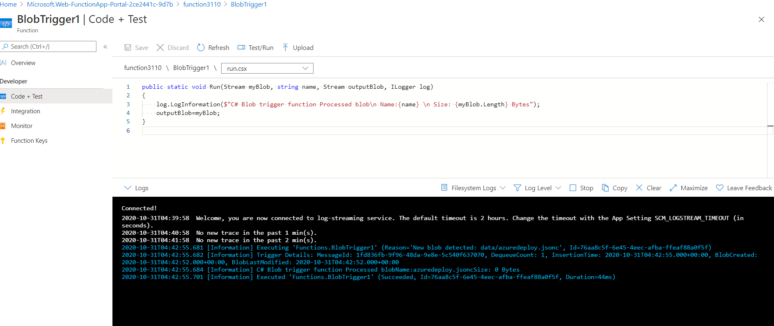

Function executed successfully!!!!

## Check the target container ‘Backup’

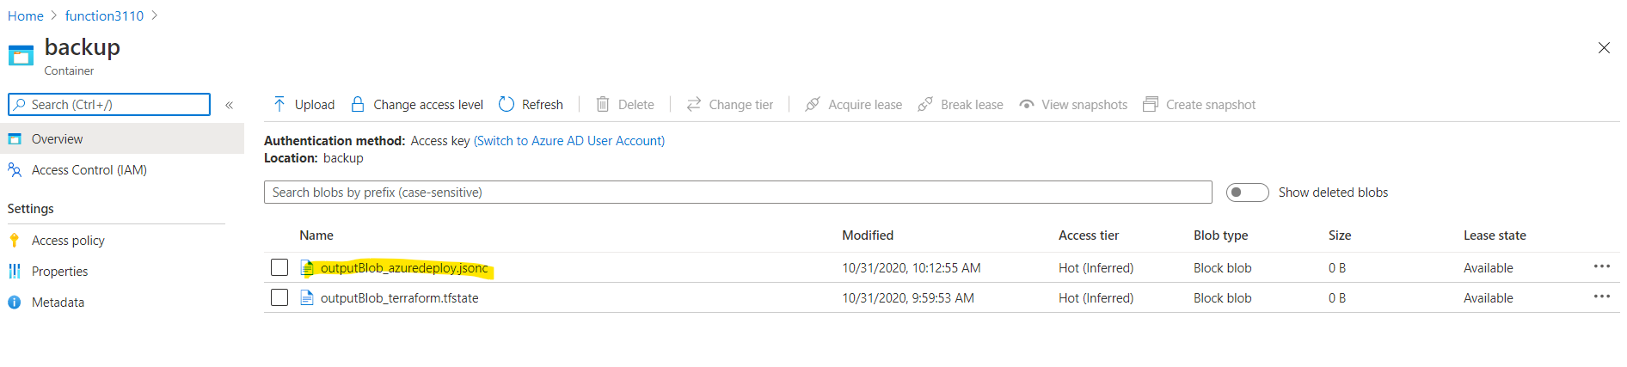

# Review: the blob uploaded in container [data] is copied to container [backup]

# Exercise 7: Clean up your subscription

## Task 1: Open Azure Cloud Shell and list resource groups

1. In the portal, select the **Cloud Shell** icon to open a new shell instance.

1. If Cloud Shell isn't already configured, configure the shell for Bash by using the default settings.

## #### Task 2: Delete a resource group

1. Enter the following command, and then select Enter to delete the **Serverless** resource group:

```powershell

az group delete --name Serverless --no-wait --yes

```

1. Close the Cloud Shell pane in the portal.

#### #### Task 3: Close the active application

1. Close the currently running Microsoft Edge application.

# > **Review**: In this exercise, you cleaned up your subscription by removing the resource group that was used in this lab.

[azure-functions-core-tools]: https://docs.microsoft.com/azure/azure-functions/functions-run-local

[azure-functions-core-tools-new-function]: https://docs.microsoft.com/azure/azure-functions/functions-run-local#create-func

[azure-functions-core-tools-new-project]: https://docs.microsoft.com/azure/azure-functions/functions-run-local#create-a-local-functions-project

[azure-functions-core-tools-start-function]: https://docs.microsoft.com/azure/azure-functions/functions-run-local#start

[azure-functions-core-tools-publish-azure]: https://docs.microsoft.com/azure/azure-functions/functions-run-local#publish